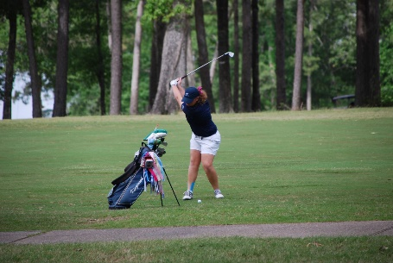
2023
Atascocita Golf Club
Junior Golf Camp

Dates: Session I June 19-21 Session II July 17-19

Time: 9:00 Am to 12:30 Pm (Lunch Included)

Ages: Boys and Girls ages 7 - 15

Objective: Our primary purpose is to have fun in the growth and development of their golf skills with focus on the full swing, putting, chipping, rules ,etiquette, and fundamentals.

Cost per session: $200.00 (2nd Child) $175.00

Email johnanks624@gmail.com to sign up

